**API End Points and Communication**

**Day 11: 14 March 28**

Creating new spring boot project

Product CRUD Operation : Insert, delete, update and retrieve etc.

Starter -🡪 Web Starter -🡪 web application features

Starter -🡪View , Thymeleaf -🡪 for view purpose

Starter 🡪 JDBC Starter : which provide features as DataSource or JdbcTemplate

Or

Starter -🡪 JPA starter 🡪 which provide core JPA or Spring JPA Data features.

Dependency 🡪 My SQL Connector

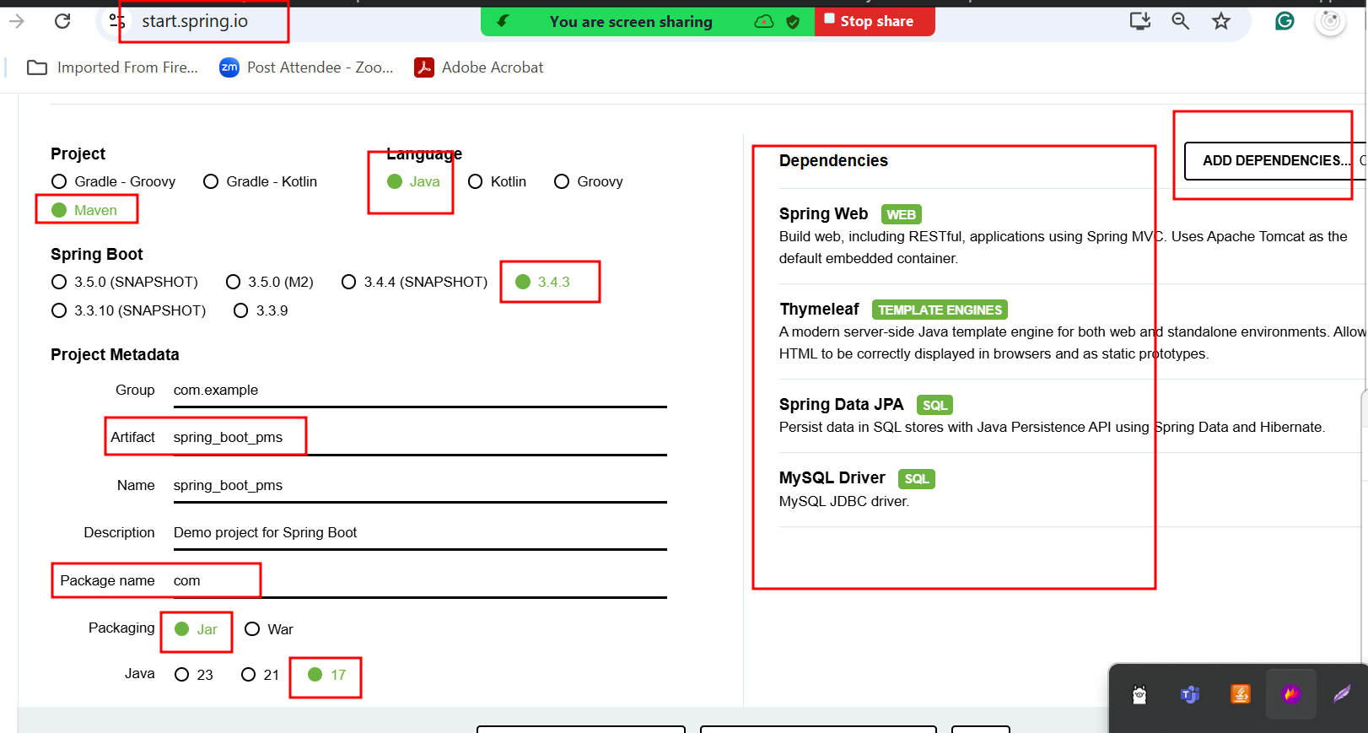

Thymeleaf provide lot of pre defined tags which help to do dynamic work on html page. If we want to use that features first we need to refer to online URL as

<http://www.thymeleaf.org>

spring boot provided one of the pre defined API as Model. which contains some method which help to share the data or information from controller to view as thymeleaf.

**Dao layer**

1. Core jdbc
2. DataSource using spring
3. JdbcTemplate using spring
4. Jpa using spring
5. Spring JPA Data

Spring JPA Data module base upon JPA. Spring JPA data

Provided two core interfaces ie CrudRepository as well as JpaRepository. These interfaces base upon Java 8 features. They provided default implementation of all crud method like insert, delete, update and retrieve.

If we want to use spring jpa data features we need to make normal interface and that interface must be extends JpaRepository or CrudRepository.

JpaRepository take 2 generic type 1st entity class and 2nd that column data type which consider as PK.

@RequestParam: it is use to receive the value from query param